ASSIGNMENT DOCUMENTATION MYSQL
BY MATHILAKATH SHARAN
Table Creation (CREATE)
Table Alteration (ALTER)
Table Renaming (RENAME)
Table Truncation (TRUNCATE)
Database and Table Dropping (DROP)

Constraints
Database Recreation
Departments Table Constraints
Location Table Constraints
Employees Table Constraints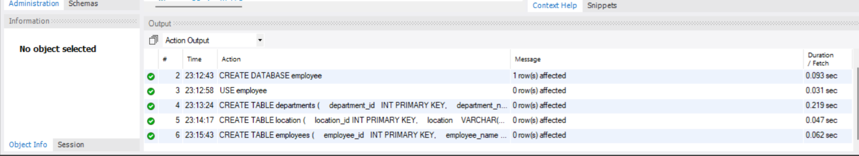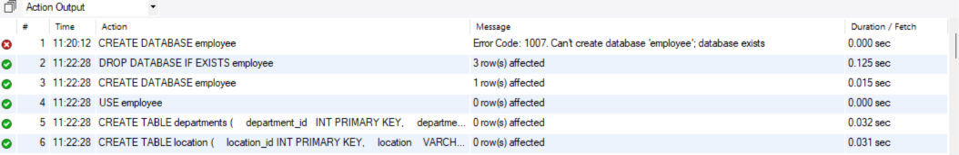
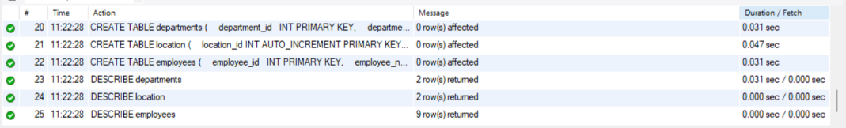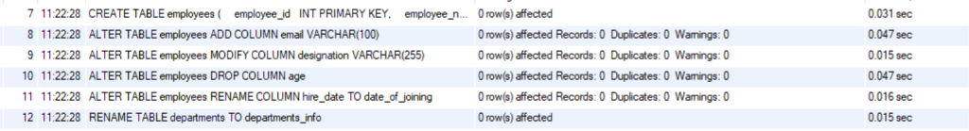
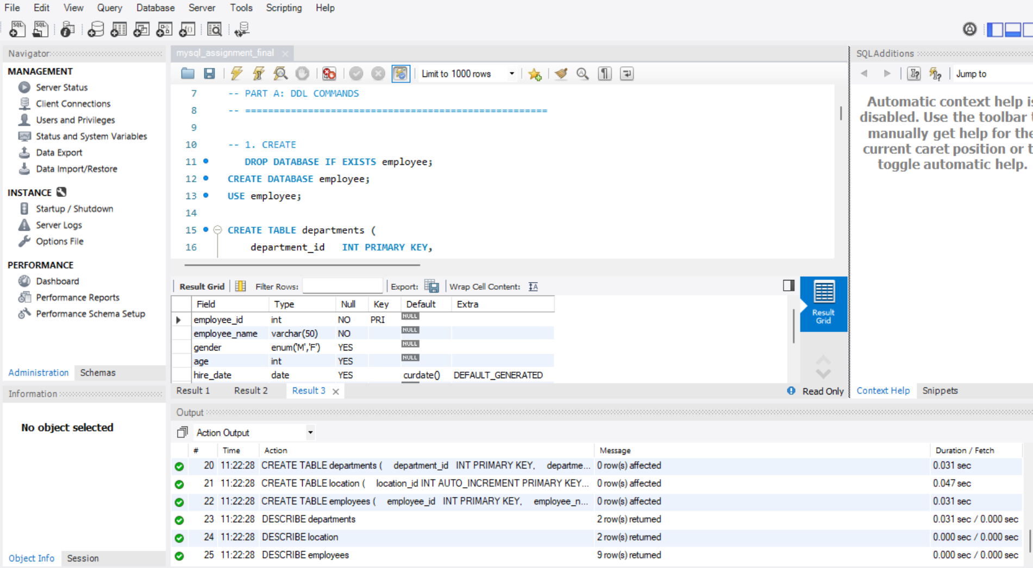
Finished page

